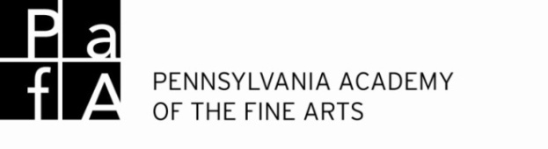

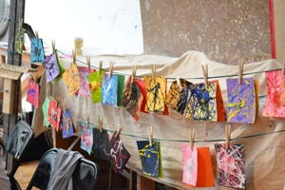 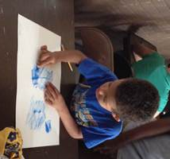

**Summer Art Camp 2015**

Parent Orientation Guide

The following information is provided to answer most of the questions you may have as you prepare your camper to attend ***PAFA Art Camp***. The leading counselor and Camp Director are always available to talk to you and answer specific questions about your child’s day at camp.

**Drop Off**

Drop off is between 8:30am-9am. **Camp starts at 9am**

Please drop your camper off no later than 9am so that they are able to participate in the full day of camp and don’t miss out on important information. Campers may be dropped off in front of the Historic Landmark Building and check in with the staff that will be stationed in front of the building and inside to receive and direct campers to the auditorium. Lead counselors will take their group from the auditorium to the art studio at 9 am.

**Pick Up**

Pick-up is between 3pm and 3:15pm. **Camp ends at 3pm**

Don’t be late! If your camper is not picked up by 3:15 pm, they will join the after-camp group and you will be charged an after-camp fee of $20. Campers should be picked up in front of the museum at 3pm. Authorized pick-up guardians are required to show ID when signing out campers. **Campers will only be allowed to leave with people who are authorized by written permission of the camper’s legal guardian.**

If you are **driving**, please pull your car up next to the curb in front of the Hamilton Building (128 North Broad Street) and wait for a staff member to come to you with the sign out sheet. Your camper(s) will be escorted by another staff member out of the building and to your car. If you are **walking**, please see the staff that will be stationed in front of the Historic Landmark Building (118 North Broad Street) and sign out your camper(s) with them. Your camper(s) will then be escorted out of the building to you. A map is attached to this orientation guide.

**After-care**

After-care is available from **3pm-5:30pm.** Campers will have a snack and may watch a movie, play a game outside, play games inside, read, draw, etc. Campers must be picked up by 5:30. Parents/guardians will be charged $1 per minute for every minute past 5:30 that they are late. Please call 215 972 2054 to register for after-care.

**Monday Orientation**

Campers should check into their camps on Monday mornings between 8:30 and 9am. A brief introduction and orientation to the Pennsylvania Academy of the Fine Arts will take place in the auditorium between 9am and 9:15. Campers will take a tour of the buildings with their individual camps.

**Clothing**

Art camp may get messy! Please dress appropriately. Staff will make every effort to keep campers neat and clean, but campers should wear clothing that can get dirty. Also, campers may want to bring a sweater or sweatshirt in case they feel cold in the museum. Please label your child’s clothing with their name.

**Lunch and Snacks**

A mid-morning snack is provided. If you would rather send a snack with your camper, please feel free to do so.

Send in a lunch every day. We are not able to refrigerate lunches or heat lunches. Please label your camper’s lunch bag with their name.

**Communicate with camp staff and director about any food allergies your camper has.**

**Supplies**

All supplies are provided for each camp. Occasionally a lead counselor may ask you to send in something from home if you have it.

**Discipline/Behavior**

We try to keep disciplinary issues minimized and to help children monitor their own behavior. Camp staff is trained to model and enforce age-appropriate behavior guidelines and reflective communication. We encourage self-control, self-direction, responsibility and cooperation. We will do our best to provide behavioral support to any student demonstrating a need or disrupting a camp.

Aggressive physical behavior such as fighting, hitting or biting will not be tolerated. Staff members will intervene immediately should this type of situation occur in order to protect all of the children and encourage more acceptable behavior. Parents will be informed if such an incident occurs. If the child’s behavior is extremely disruptive and/or harmful to themselves or others, a parent may be asked to remove the child from camp for the remainder of the day. Open communication between guardians and camp is considered key in terms of effective discipline. By signing the Behavior/Field Trip/Photo Release form you are agreeing to the terms listed above.

PAFA reserves the right to ask a disruptive camper to withdraw from camp and if such a situation occurs, will refund payment for the remaining days of camp.

**Camper Health and Information Forms**

All camper information forms must be turned in by June 20th. Campers will not be permitted to attend with out these completed forms.

**It is also very important to provide camp staff with accurate health information about allergies as well as any emergency medications that allow your child to participate in trips or activities outside, i.e. epi-pen, asthma inhaler, etc.**

**Camp Trips**

By signing the trip release form you are giving permission for your camper to go on field trips with their camp under the close supervision of lead and assistant counselors. Parents will be notified at least 1 day prior to the time and location of the trip. It is important that campers follow the directions of their counselors and pay close attention on trips.

**Friday Exhibit**

Each Friday at 2pm family members are invited to an exhibit of work created that week. Announcements will be sent out prior to the show. All projects must be taken that day. You can receive a discount on parking fees by parking in a Parkway Corporation parking lot and having your ticket validated at the front desk of the museum.

**Lost and Found**

There will be a Lost and Found kept in the Director’s Office. Please call 215-972-2054 if you need assistance in locating a lost item. **Unclaimed items will be discarded one week after the end of camp.**

**PLEASE LABEL YOUR CHILD’S BELONGINGS WITH THEIR NAME!**

**Important Numbers**

Katie Samson, Camp Director Office: **215 972 2054,** Mobile: **520 495 9520** Email: [artcamp@pafa.org](mailto:artcamp@pafa.org)

Kate Petrillo Summer Camp Assistant (part-time) Office: **215 972 2036**

Monica Zimmerman, Director of Museum Education Office: **215 972 2105**

Historic Landmark Building Front Desk **215 972 2060**

Hamilton West Lobby **215 972 2100**

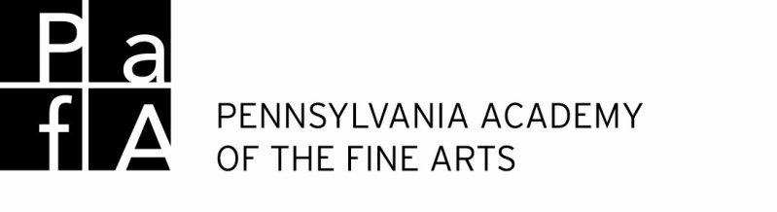

**New dismissal procedures**

Your child’s safety is always our first priority. This year we will be asking you to show your photo ID when you come to pick up your camper. There will be 2 staff members at each station to help you sign out. Another staff member will escort your child out to you. Your patience is appreciated.

* **Vehicle** pick up will happen in front of the **Hamilton Building.**
* **Walk up** pick up will happen in front of the **Historic Landmark Building.**

VINE ST VINE ST

**Vehicle**

**Pick Up**

B

R

O

A

D

S

T



**Historic Landmark Building PAFA 118 N. Broad St.**

ARCH St ARCH ST

S

W

E

N

+

Empty Lots

15th

15th

Friends Center

Hahneman Hospital Parking Lot

Jake’s Pizza

Street Level Parking Lot (will accept validation from PAFA)

RACE ST

142 Garage Valet Parking Garage (not validate)

Pennsylvania Convention Center

RACE ST

**Samuel M.V. Hamilton Building**

**PAFA 128 N. Broad St**

Lenfest Plaza

**Drop Off**

**Walk Up Pick Up**

B

U

R

N

S

S

T

7-Eleven

Parkway Self Park Garage (will validate)

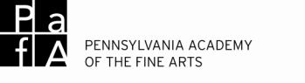

Page 1

**Summer Art Camp**

**Camper Information**

Contact/Transportation Release

Please fill out this form and return it to The Pennsylvania Academy of the Fine Arts as soon as possible. If any information changes before or during your week(s) at camp please notify Summer Camp staff.

________________________________________________________________________________________Camper Last Name Camper First Name Age/Grade

________________________________________________________________________________________Address City State Zip Apt.#

**Sibling at Camp?**

Circle one.

Yes no

Sibling Name

Camp

**Camps**

Week 1______________________________________________________aftercamp: yes no

Week 2______________________________________________________aftercamp: yes no

Week 3______________________________________________________aftercamp: yes no

Week 4______________________________________________________aftercamp: yes no

Week 5______________________________________________________aftercamp: yes no

Week 6______________________________________________________aftercamp: yes no

Week 7______________________________________________________aftercamp: yes no

**Parent/Guardian** _________________________________________________________________________________________________________________________Last First Phone

_________________________________________________________________________________________________________________________Address City State Zip Apt.#

**Parent/Guardian** ________________________________________________________________________________________Last First Phone

________________________________________________________________________________________Address City State Zip Apt.#

By my signature I certify that all information is approved and correct unless otherwise indicated. I release the Pennsylvania Academy of the Fine Arts from any liability._________________________________/_____/_____

Parent/Guardian Signature Date

____________________________________________

Name Phone

____________________________________________

Name Phone

____________________________________________

Name Phone

**Pick-Up Authorization**

On the right, please list the names of any person authorized to pick up your child in addition to parents/guardians ***or*** check the box below to authorize your camper to sign themselves out and leave on their own.

Camper may sign themselves out.

**Emergency Contacts**

Please list 2 emergency contacts. These should not be parents or guardians.

Name Phone

Name Phone

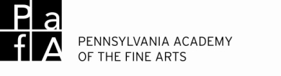

Page 2

**Summer Art Camp**

**Camper Information**

Health Information/Emergency Release

Please fill out this form and return it to The Pennsylvania Academy of the Fine Arts as soon as possible. If any information changes before or during your week(s) at camp please notify Camp staff.

___________________________________________________/______________________________________________

Child’s Last Name Child’s First Name parent/guardian name phone

___________________________________________________/______________________________________________

Child’s Physician’s Name phone

Does your child have health insurance coverage right now? (Circle One Answer)

Date of last **tetanus shot**

_______/_______/___________

**YES**  **Insurance Company, HMO, etc.**

Name of Insurer_______________________________

Policy Number________________________________

Group Number_________________________________

**YES**  **Medical Assistance**

Medical Assistance Contact Information_________________________________________

**NO**  **We do not have coverage**

**Allergies** Please list allergies along with reaction and management.

allergic to reaction

management

allergic to reaction

management

**Restrictions**

Please list all dietary and activity restrictions.

**Medication Information**

Please list all medications (including over the counter or nonprescription drugs) taken routinely. Bring enough medication to last the entire time at camp. Keep it in the original packaging that identifies the prescribing physician, the name of the medication, the dosage and the frequency of administration. All medications, including over-the-counter/nonprescription, must be turned in to the camp Director at registration.

____________________________________________________________________________________________________

medication dosage time/frequency

__________________________________________________________________________________________________________________________

Reason for taking

____________________________________________________________________________________________________

medication dosage time/frequency

__________________________________________________________________________________________________________________________

Reason for taking

**Special Health Information**

Please provide any additional information about the participant’s behavior and physical, emotional or mental health about which the camp should be aware. (Continue on the reverse of this form.)

I authorize Pennsylvania Academy staff to administer first aid as needed.

For the safety of your child in emergency situations, where the parent/guardian cannot be contacted immediately, I hereby give authority to the Pennsylvania Academy of the Fine Arts to obtain necessary emergency medical treatment for my child with the understanding that the family will be notified as soon as possible.

The authorization granted by this form will be used only where absolutely necessary and only after every attempt has been made first to contact the parent/guardian. In an emergency requiring immediate medical attention, your child will be taken to the nearest hospital emergency room. Your signature authorizes the transportation of your child to that hospital and your responsibility for the resulting treatment and payment.

By my signature I certify that all information is approved and correct unless otherwise indicated. I release the Pennsylvania Academy of the Fine Arts from any liability._________________________________/_____/_____

Parent/Guardian Signature Date

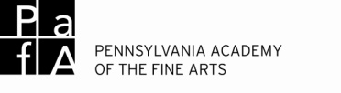

Page 3

**Summer Art Camp**

**Camper Information**

Behavior/Field Trip/Photo Release

Please fill out this form and return it to The Pennsylvania Academy of the Fine Arts as soon as possible. If any information changes before or during your week(s) at camp please notify Camp staff.

**Discipline/Behavior**

We try to keep disciplinary issues minimized and to help children monitor their own behavior. Camp staff is trained to model and enforce age-appropriate behavior guidelines and reflective communication. We encourage self-control, self-direction, responsibility and cooperation. We will do our best to provide behavioral support to any student demonstrating a need or disrupting a camp.

Aggressive physical behavior such as fighting, hitting or biting will not be tolerated. Staff members will intervene immediately should this type of situation occur in order to protect all of the children and encourage more acceptable behavior. Parents will be informed if such an incident occurs. If the child’s behavior is extremely disruptive and/or harmful to themselves or others, a parent may be asked to remove the child from camp for the remainder of the day. Open communication between guardians and camp is considered key in terms of effective discipline.

PAFA reserves the right to ask a disruptive camper to withdraw from camp and if such a situation occurs, will refund payment for the remaining days of camp.

**Field Trip Release**

I grant permission for ____________________________________________ to attend any scheduled field trips

Child’s Name

for his/her camp session. Some camp sessions will be taking walking trips to nearby sites *under adequate* *supervision.* Furthermore, for and in consideration of arrangements and provisions made for the conduct of the activity, I hereby release the Pennsylvania Academy of the Fine Arts and its representatives from all liability resulting from injury sustained by my child during such trips.

**Photo Release**

The Pennsylvania Academy of the Fine Arts gathers images throughout the year of its program participants in an effort to tell the story of our organization and our mission. We appreciate your cooperation and consent in allowing us to photograph you and your child for our use in various mediums. You have our assurance that these images will be used only for official purposes and with the respect and consideration to which you are entitled.

I,______________________________________________grant permission to The Pennsylvania Academy of

Parent/Guardian Name

the Fine Arts for full use of photographic/video images taken of me or my child, or of anyone for whom I have legal responsibility on this date.

By my signature I certify that all information is approved and correct unless otherwise indicated. I release the Pennsylvania Academy of the Fine Arts from any liability._________________________________/_____/_____

Parent/Guardian Signature Date

Please send forms as soon as possible!

**Scan and email** to: artcamp@pafa.org

**Fax:** 215-567-2429

**Mail:** Museum Education, attn: Spring Camp, 118 North Broad Street, Philadelphia, PA, 19102

**Drop them off** at the front desk of either museum building. Envelope should be labeled: Museum Education

Attn: Summer Camp