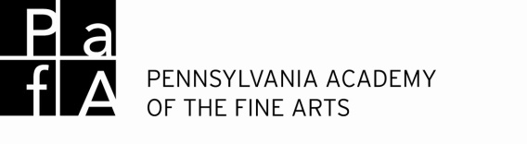
2015 Summer Art Camp
Scholarship Application

A limited number of scholarships are available for summer campers who meet special criteria. It is our sincere desire that no child be denied the opportunity to attend camp because of financial difficulties. PAFA works hard to raise scholarship funding, but we can make no guarantees. If you feel that your child qualifies for a camp scholarship, please fill out the application below for each applicable child and include a letter of recommendation from your child’s teacher. Scholarships are awarded on a first come first serve basis.

Name of Child: |  |  |  |  | Date:
Address: |  |  | City: |  |  | State:
Zip:
Name of Mother/Guardian: |  |  | Address:
City: |  | State: |  | Zip:
Phone: |  |  | Email:
Name of Father/Guardian: |  |  | Address:
City: |  | State: |  | Zip:
Gross Annual Household Income (before taxes): |  |  |  | Total number of individuals in household:
Phone: |  |  | Email:

School Name: |  | School Phone:
Teacher’s Name

Please list the camps that your child is most interested in attending in order of preference. We will try our best to honor the first camp requested. Camps are listed on our website : www.pafa.org/camp

- Week ____Camp____:_________________________________________________________________________
- Week ____Camp____:_________________________________________________________________________
- Week ____Camp____:_________________________________________________________________________
- Week ____Camp____:_________________________________________________________________________

Please tell us why your child is an ideal candidate for a Summer Art Camp scholarship.

If awarded a financial scholarship I agree to have my child write/create a thank you for the generous donations received towards the summer camp scholarship.
Parent /Guardian Signature: | Date:
Print Name:

Please attach a letter of recommendation from your child’s classroom teacher nominating your child for a Summer Art Camp scholarship.

Email to: csamson@pafa.org [Scholarship application in the subject line]
Fax to: 215 567 2429 [ ATTN: Summer Art Camp]
Mail to: ATTN: Art Camp, Museum Education, The Pennsylvania Academy of the Fine Arts, 128 North Broad Street, Philadelphia, PA, 19102
Call with Questions: 215 972 2054

