PAFA YOUTH COUNCIL 2020/2021 Application

Youth Council is a free after school program available to students in grades 9-12 that offers opportunities for paraprofessional experiences within PAFA’s museum, including organizing events and programs for the museum’s expanding teen audience.

To be considered, students must submit a completed application, and if chosen, come in for an interview with the Teen Programs Coordinator. From there, students will be notified via email of their acceptance.

What is the Youth Council?
The Youth Council is a small group of teens who meet weekly to explore the relationship between their peer group and art museums. They will have privileged access to PAFA’s art collection, staff and resources. In addition to creating, discussing and exploring art, they assist with planning and hosting events geared towards teens.
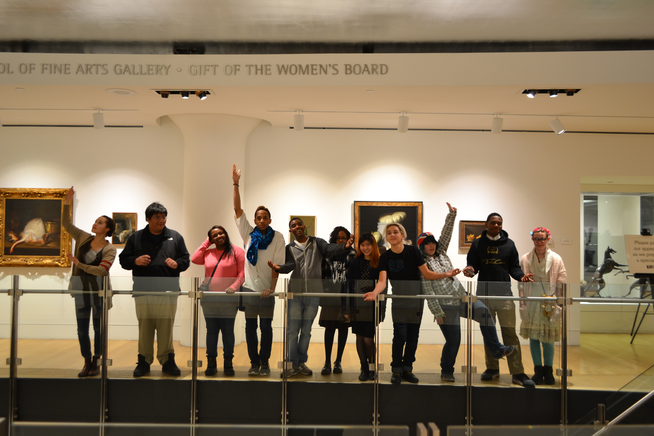

Additional program highlights include:
- Special access to PAFA staff and resources.
- Studio visits with practicing artists.
- Curating an art exhibition.
- Field trips to other cultural institutions.
- 1 year Family Membership upon completion
of the program.

Important Dates:
- Due to Covid-19 restrictions, the Youth Council will meet on Wednesdays via Zoom from 4:00 – 5:15pm from October through December of 2020. In 2021, PAFA will reassess whether meetings will be held in person or online. Youth Council will run through the beginning of May 2021.
- Applications are due Friday, September 11th. Early applications are encouraged.
- Students will be notified of their status via email by September 25th. No phone calls please.
∙ The first Youth Council meeting will take place on Wednesday, October 7th at 4pm.

Requirements
- Applications are due Friday, September 11th. Please email them to Kristina Murray at kmurray@pafa.org
- Candidates must be a teen and currently in grade 9, 10, 11 or 12.
- Candidates must complete this application in full.
- Eligible candidates must complete an interview via Zoom or phone call.
- Candidates MUST be available Wednesdays from 4:00 – 6:00 from October to May.

APPLICANT INFORMATION all fields required
First Name__________________________ Last Name _______________________________
Nickname __________________________ E-Mail ___________________________________
Street __________________________________________________ Apt # ______________
City: _______________________________ State: ______________ Zip:________________
Birth Date ___/___/_____ Grade: ______ School: _________________________________
Preferred Pronoun ___________________ Cell Phone ______________________________
How did you hear about this opportunity? _______________________________________ Ethnicities (optional) _________________________________________________________

Parent /Guardian Information all fields required
First Name:__________________________ Last Name: ______________________________
Relationship to Applicant ______________________________________________________
Cell Phone __________________________ E-Mail _________________________________
Street __________________________________________________ Apt # ______________
City: _______________________________ State: ______________ Zip:________________
This person is an emergency contact Yes No
2nd Parent / Guardian Information optional
First Name:__________________________ Last Name: ______________________________
Relationship to Applicant ______________________________________________________
Cell Phone __________________________ E-Mail _________________________________
Street __________________________________________________ Apt # ______________
City: _______________________________ State: ______________ Zip:________________
This person is an emergency contact Yes No
Parental / Guardian Consent required
Field Trip Release I (print name) _____________________ give permission for my child (child’s name) _____________________ to attend any scheduled field trips as part of the Youth Council program. Furthermore, for and in consideration of arrangements and provisions made for the conduct of the activity, I hereby release the Pennsylvania Academy of the Fine Arts (PAFA) and its representatives from all liability resulting from injury sustained by my child during such trips.
Photo Release The Pennsylvania Academy of the Fine Arts gathers images throughout the year in an effort to tell the story of our organization and our mission. We appreciate your cooperation and consent in allowing us to photograph you and your child for our use in various mediums. These images will be used only for official purposes and with the respect and consideration to which you are entitled. I grant permission to PAFA for full use of photographic/video images taken of me or my child, or of anyone for whom I have legal responsibility on this date.
Support I acknowledge the commitment my child intends to make to this 8 month program and if they are chosen, I will support their weekly attendance to the best of my ability.

Parent Signature ________________________________________ Date ______________________

Please answer the following questions in the space provided.

- Why do you want to be on PAFA’s Youth Council?
____________________________________________________________________________________________________________________________________________________________________________________________________________________________________________________________________________________________________________________________________________________________________________

- Please read the “What is the Youth Council?” section. From that description, what are you most excited about and why?
____________________________________________________________________________________________________________________________________________________________________________________________________________________________________________________________________________________________________________________________________________________________________________

- Read all the options below and circle the 6 that most apply to you.

I love art. I’m reserved. I’m confident.
I’m organized. I like art. I communicate well.
I love to read. I’m curious. I’m a neat freak.
Reading is okay – it depends. I’m a planner. Art is new for me.
I am an artist. I like working with others. I like sports.
I’m okay getting messy. I am creative. I like poetry.
I like group projects. I like structure. I like to dance.
I work better alone. I’m a collaborator. I don’t like attention.
I’m logical. I’m a problem solver. I’m shy.
I change my mind a lot. I’m serious. I like science.
School is okay. I like public speaking. I enjoy school.
I’m close to my family. I encourage others. I’m thoughtful.
I’m into technology. I like meeting other people. I’m reserved.
I visit art museums. I’m enthusiastic. I’m a good listener.
I’m responsible. I’m unsure about the future. I like quiet time.
I’m carefree. I like sharing my ideas. I’m self motivated.
I’m a musician. I prefer listening over talking. I’m into history.
I’m a poet. I like math. I’m a leader.
I’m outspoken. I’m open minded. I’m usually on time.
I like to be active. I’m social. I like research.
I like to write. I’m tolerant of differences. I try new things.

- Describe your two best qualities:

Quality 1. ________________________________________________________________ __________________________________________________________________________________________________________________________________________________Quality 2 _________________________________________________________________
_________________________________________________________________________
________________________________________________________________________

- Describe two qualities you’d like to improve upon and why:

Quality 1. ________________________________________________________________ __________________________________________________________________________________________________________________________________________________Quality 2 _________________________________________________________________
_________________________________________________________________________
________________________________________________________________________

- What do you see yourself doing in 10 years? _________________________________________________________________________
_________________________________________________________________________
_________________________________________________________________________

- What other activities, sports or clubs do you already participate in? Please list the activity and be specific about what months/days/times you participate.
Example: Basketball on Tuesday and Fridays starting in October ending in January.
____________________________________________________________________________________________________________________________________________________________________________________________________________________________________________________________________________________________________
________________________________________________________________________________

The Youth Council is a big commitment. In order for council members to get the most out of the program and participate in every project, attendance at each session is mandatory.

YES, I will be available every Wednesday from 4–6pm from October – May.

Student Signature __________________________________________ Date _____________

