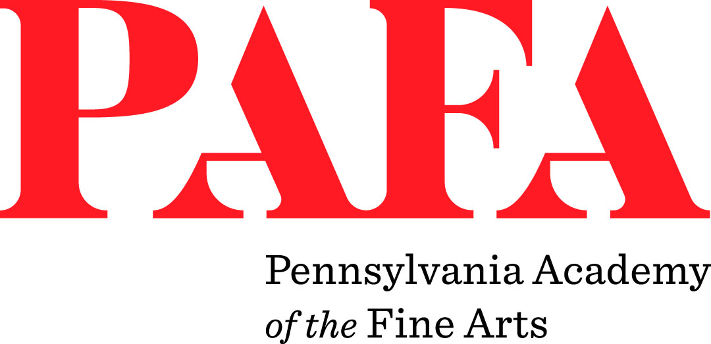

Malini Doddamani
Chief Marketing Officer
(215) 972-2013
mdoddamani@pafa.org

FOR IMMEDIATE RELEASE

Ancient History of the Distant Future Opens at PAFA September 26th
PHILADELPHIA (August 21, 2019) -- The Pennsylvania Academy of the Fine Arts (PAFA) is pleased to announce the opening of Ancient History of the Distant Future, a major exhibition featuring work by contemporary artists installed in spaces throughout PAFA's 19th century Historic Landmark Building and in conversation with selections from PAFA's permanent collection. Ancient History of the Distant Future will be on view at PAFA in the Historic Landmark Building on North Broad Street, from September 26, 2019 through February 2, 2020.
Curated by Jodi Throckmorton, PAFA's Curator of Contemporary Art, and Joseph del Pesco, International Director of KADIST, the exhibition features work by artists Lawrence Abu Hamdan, Matthew Buckingham, Cassils, Enrique Chagoya, Lenka Clayton and Phillip Andrew Lewis, Minerva Cuevas, Alex Da Corte, Cynthia Daignault, Mario Garcia Torres, General Idea, Mungo Thomson, Adrian Villar Rojas, and Carla Zaccagnini.
"We are thrilled to be the first museum in Philadelphia to work with the esteemed artists collected by KADIST, a perfect partner for PAFA since we are an institution which has always been committed to the artists of our time, " said Brooke Davis Anderson, Edna S. Tuttleman Director of the Museum.
The works in the exhibition point back—critically, quotationally, or inspirationally—to historical artworks, particularly those that find new relevance in the present, or play temporal tricks. The artists consider the possibility of art to speak to history-at-large, as a strange and evolving field of thought, not just art history. The notion of 'making history' continues to shift and change, its implications informed by the changing values of society. Using a variety of approaches, the artists in the exhibition address current social or political forces through allegory, juxtaposition, or recollection. A return to the women's suffrage movement, for example, that led to an amendment to the US constitution in 1919, one hundred years ago, giving women the right to vote, is the focus of Argentinian artist Carla Zaccagnini.
"It is such a pleasure to collaborate with Joseph del Pesco and KADIST on this exhibition which brings the ideas of these exciting contemporary artists into dialogue with PAFA's historic architecture and collection," said Throckmorton. "The artists provoke a reconsideration of the historical American artworks on display, as well as question historical methods and common museum narratives."
PAFA's collaborator in this exhibition, KADIST, is a non-profit organization based in Paris and San Francisco. Joseph del Pesco is currently the Director. KADIST is dedicated to exhibiting the works of artists represented in its collection and developing collaborations with artists, curators and art organizations around the world. Ancient History of the Distant Future is their first project in Philadelphia.
"To organize an exhibition thinking about history in the first art museum and school in the US is such a unique context and ideal setting for this international group of artists, who research the echoes from the past that inform our present," said del Pesco. "KADIST is tremendously grateful for the adventurous spirit of PAFA, and in particular Jodi Throckmorton, for the fruitful collaboration."

About PAFA
Founded in 1805, the Pennsylvania Academy of the Fine Arts is America's first school and museum of fine arts. A recipient of the National Medal of Arts, PAFA offers undergraduate and graduate programs in the fine arts, innovative exhibitions of historic and contemporary American art, and a world-class collection of American art. PAFA’s esteemed alumni include Mary Cassatt, Njideka Akunyili Crosby, Thomas Eakins, William Glackens, Barkley L. Hendricks, Violet Oakley, Louis Kahn, David Lynch, and Henry Ossawa Tanner.

